Mallee Phallies Orchid Importers
Keva & Lesley Lloyd, 13 Glenwill Drive, Epsom, Vic. 3551

Email: malleephallies@kevalloyd.com.au
Web: www.kevalloyd.com.au/malleephallies
Mob: 0418 579998

Deflasking Suggestions ….
For “Whisky” bottle flasks (Thailand generally) - I wrap them in newspaper, preferably early in the day, put them in a plastic bag and give the bottom a sharp rap upwards with a hammer! The glass will break fairly easily and you can then just remove the seedlings and agar in a lump. Wash the agar off carefully with tepid water and lay the seedlings to dry on paper towel.
Towards evening …. or the next day if the seedlings haven’t dried sufficiently … I would prepare a largish pot, say 6-8" …. depending on the number and size of the seedlings of course – there’s no point in using a large pot if a smaller one will do!, … half fill with orchid bark, coconut fibre, perlite, etc. and dampen thoroughly. I then place a layer of damp sphag moss on top ... about 1". I then place the seedlings around the outer portion of the pot, longer roots inwards if possible. I then put a good lump of sphag in the middle of the pot/seedlings to cover the roots. Then, gently holding the leaves inwards, place another narrow strip of sphag around the outer edges of the pot. Gently pat down, not too tightly.
I then place the whole lot in a large ziplock bag and close it leaving about an inch or two open. Place in a bright, warm spot. Then basically forget about it until there is no longer any condensation on the plastic or the top layer of sphag has dried out. That's when it's time to water again .... NO SOONER!
The reason for doing this is to recreate a similar environment for the seedlings as to what they had become used to, inside their flasks …. a warm, humid climate! I have actually had seedlings flower inside these bags!
When you feel that they've settled (and seedlings can stay in this environment for months or longer!) and have adapted to their new environment and grown somewhat, it's time to plant them up in your preferred medium in as small a pot as possible. That's the time when you can also start to think about very week fertilizer of your preference.

For Erlenmeyer flasks (Taiwan generally) - similar apart from seedlings which have strong flexible roots - you can usually extract these through the neck of the flask one at a time. Firstly agitate gently with tepid water to break up the agar. Paphs will need to have the flask broken as above - their roots are too brittle.
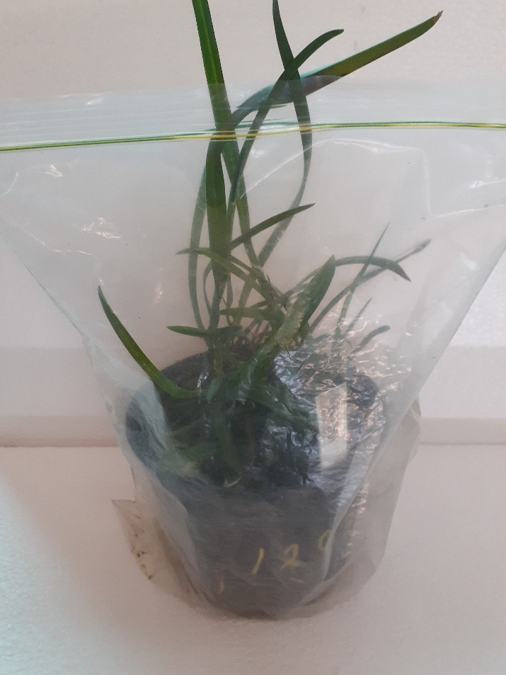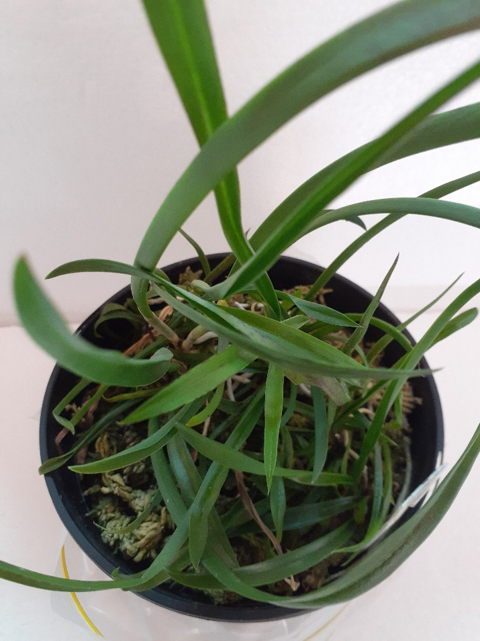

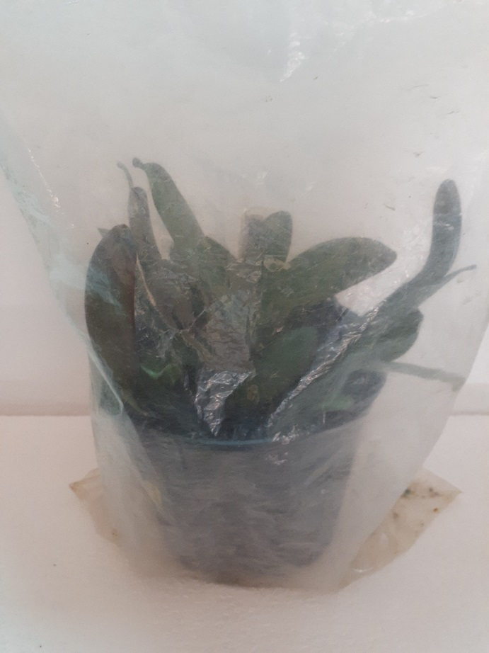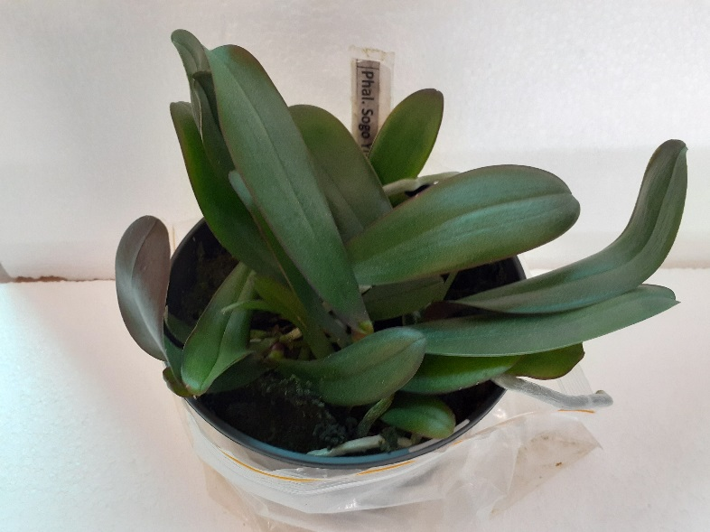

These are the results some months later – seedlings to sell or pot up!

Happy growing!

